CMP6200/DIG6200
Individual Undergraduate Project (FYP)
Interim Progress Review
[Project Title Here]

Student Name: Joshua Barnes
Student ID: 23130205
Course: Computer Games Technology
Supervisor: Jan Krasniewicz
Reporting Period: [Date of Proposal Submission] to [Date of this Review]

1.0 Log of Completed Activities & Milestones
The first 3 weeks of this project involves the design phase of the project:
- Week 1 – 05/11/2025: Involves the creation of a powerpoint document to begin documenting resources found online. This followed the beginning of finding resources for Procedural Generation(PCG).
- Week 2 – 12/11/2025: This involved determining what AI framework would be used for this project. It was determined after research that GOAP would be used for development and that this would be used for both versions of the AI to ensure fairness and integrity to the project. Then a unity package was discovered that provided the basic structure for GOAP to make the process quicker.
- Week 3 – 19/11/2025: This week was spent researching how to approach developing an AI that interprets environmental data. It involves documenting the best approach in development and what features the AI would require to be successful.
The next 3 weeks of the project involves half of the development for stage 1 which involves PCG and simple AI creation:
- Week 4 – 26/11/2025: This was the initialisation of development. This involved setting up the unity project and having this then linked to a personal GitHub repository for ease of access.
- Week 5 – 05/12/2025: This involved setting up the PCG. More specifically having the level randomly generated on a singular tile and then moving onto a large scale level that is procedurally generated and textured according to terrain types.
- Week 6 – 09/12/2025: This finalised the process of PCG by having assets procedurally generated onto the level based on what terrains they were on and creating appropriate pathways
Key tasks completed during this period include:
  - Design: Research PCG to find resources online that can be used.
  - Design: Determine which framework will be used for the AI
  - Design: Research online for a template for AI framework
  - Development: Creation of a procedurally generated level.
  - Development: Creation of procedurally generated assets
2.1 Progress Against Original Timeline
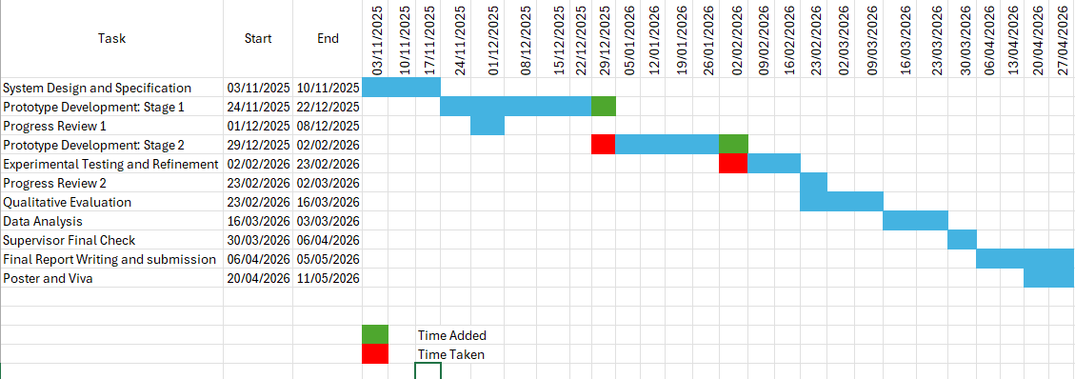
Current Project Status (select one and briefly explain):
☐ Behind Schedule: Development Stage 1: Development of the AI. Technically still on track but predicted to fall behind.
2.2 Challenges Encountered & Resolutions

Challenge Encountered | Impact on Project | Action Taken / Planned Solution
Other modules conflict due to earlier deadlines | Requires an estimated extra week in development stage 1 | Extra week allocated to Development stage 1 which is taken out of Refinement week
Table 2.1: Example of how to represent the challenge encountered and resolutions (do not copy these challenges)
3.0 Action Plan: Goals for Next Period
Moving forward, before the next progress review, it is predicted that the development stages will have been completed and as an addition recruitment of testers will be completed and the questionnaire would have been as well.
Key objectives to be met by [Date of next deadline/meeting]:
- Development Stage 1 Completion
  - Simple AI to have been implemented
- Development Stage 2 Completion
  - Completion of AI that interprets level information
- Evaluation: Recruitment of participants
- Evaluation: Creation of questionnaire
4.0 Other Considerations
Some considerations have come up during development which is the theme of the levels that are being tested. It was initially decided that the level will be a PVE FPS. However, the participants may lack the experience in this genre so a consideration may be to change the theme to something a lot more user friendly or make recruitment tailored to experienced users
- Questions for Supervisor
The main question to propose follows 4.0 Other considerations. What theme/ genre would be recommended to expand the recruitment of participants that can provide relevant results.

